Date | Classification  Debug /  Creation /  Testing / | Evidence | Description of work done | Description of problem solved if applicable
29/07 | Creation | 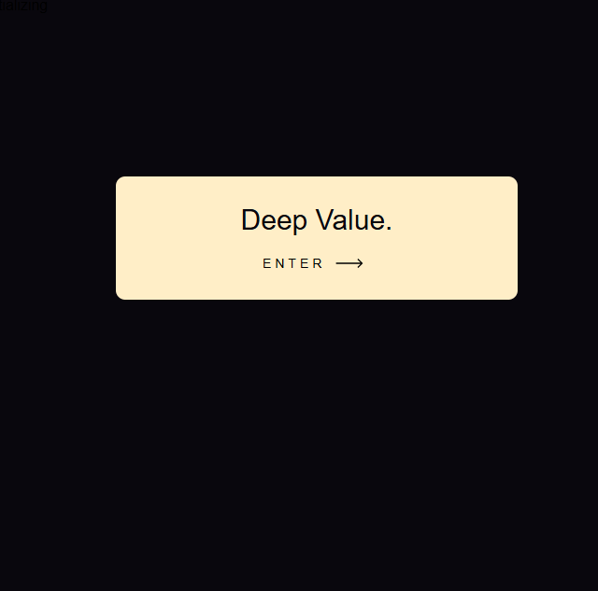 | Coding the basic version of the home page of my Investment Journal  I added a button which I found on this website Button by alexmaracinaru made with CSS | Uiverse.io
29/07 | Debug | 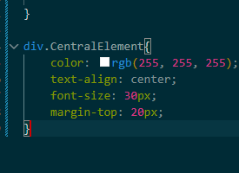  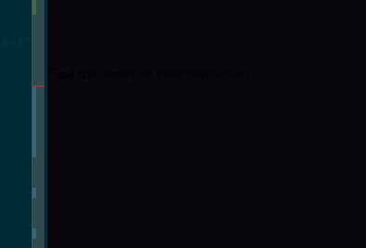 | Debugging why the text isn’t showing up properly | I needed to remove the space between Central and Element to ensure the syntax was correct so that my div could detect the right CSS and apply it
2/08/26 | Stylistic additions | 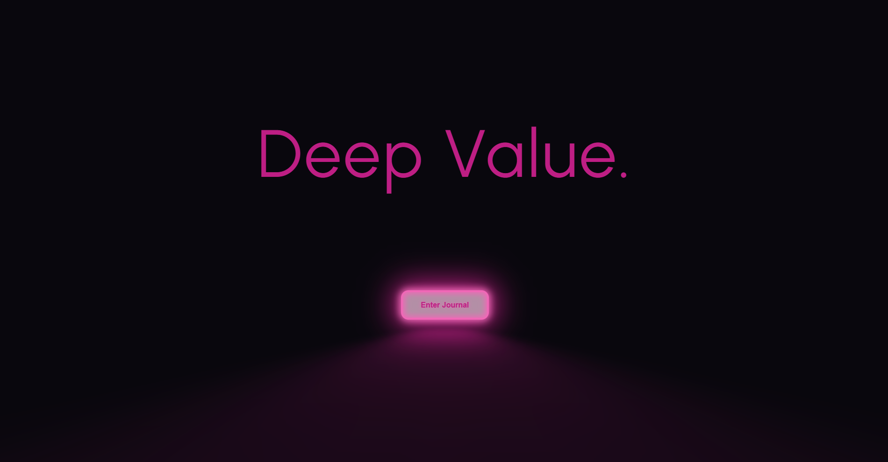 | I added a new button that looks like a neon sign and gave the websites landing page a more distinctive colour scheme, now it feels unique.
3/08/26 | Stylistic additions |   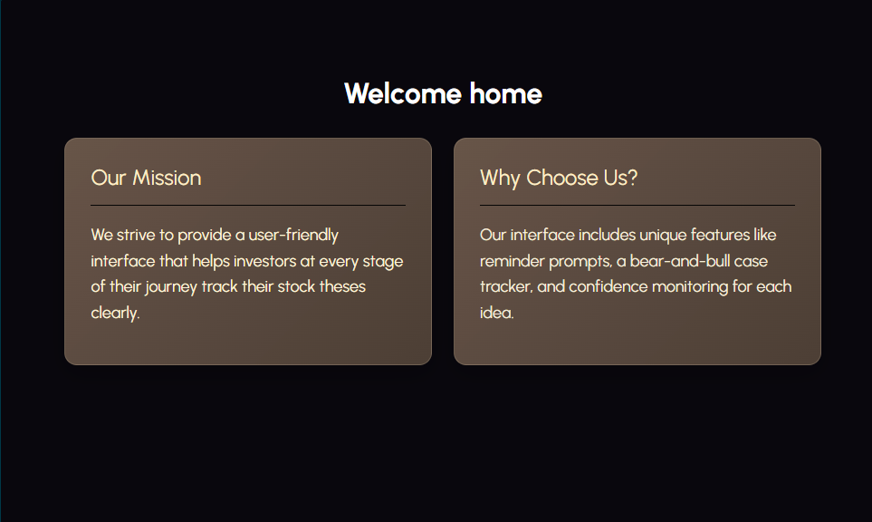 | I updated the colour schemes, I think this is a good change. I think the landing page especially looks really refined now.
3/08/26 | Stylistic additions | 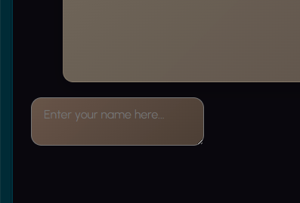 | I need a way for users to enter their name so that the system has a more personal touch. I will do this through a typing box and a send / enter button. | I will do this through some basic textarea code tutorial found at this website: HTML Text Box Code  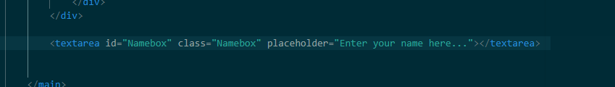
3/08/26 | Debug | 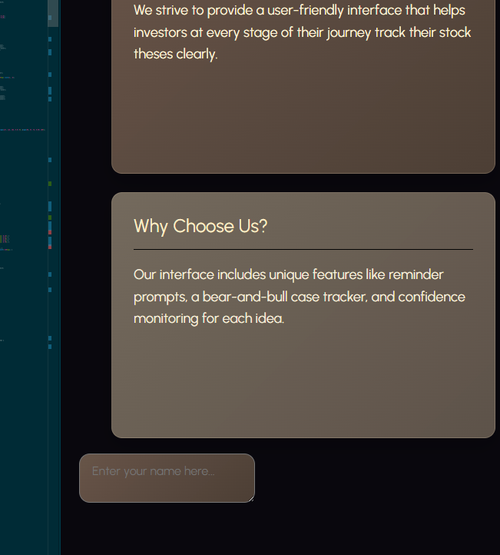 | The Text box is not aligning to the centre of the page when I try to use align-items: centre; | I needed to add these four lines of code under home-shell rather than Namebox, because the name box is also under home-shell. I made some changes to the layout so that the main content is now centered on the page, rather than being stuck too high up or following the usual flow of the document. This gives it a neater look. I also tidied up the container to make it look more streamlined and kept the spacing consistent, which makes the page feel more polished. The headings and content blocks look more organized and the whole page is easier to read and more balanced.  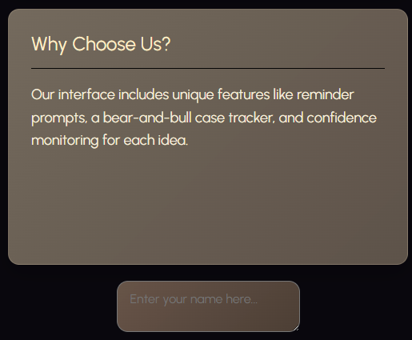  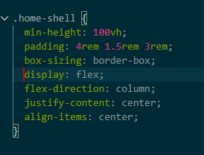
4/08/26 | Creation | 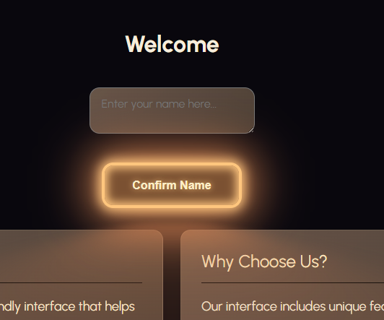  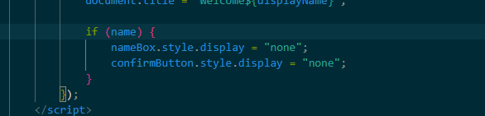 | I added a feature to let the user enter their name to give the system a more personal touch. This allows the user to type their name into the box below the welcome sign, press confirm name, and then it personalises the welcome message like welcome (Name). After the system listens for the button click it reads the entered name and puts it into the welcome message framework. The button and textbox hide after a name has been entered to make the interface appear more cleanly.
6/08/26 | Creation |  | I added a basic stock ticker list to display the stocks and their percentage changes and values
10/08/26 | Stylistic additions | 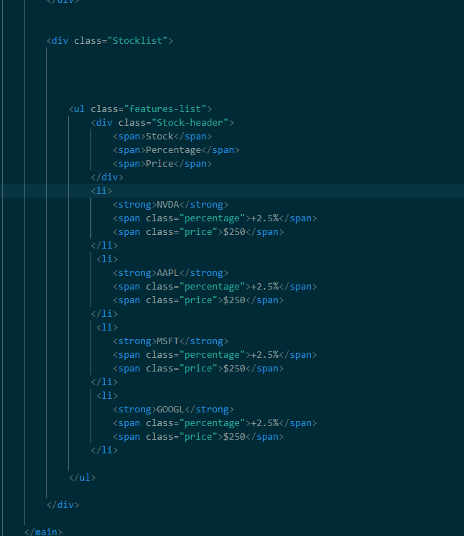  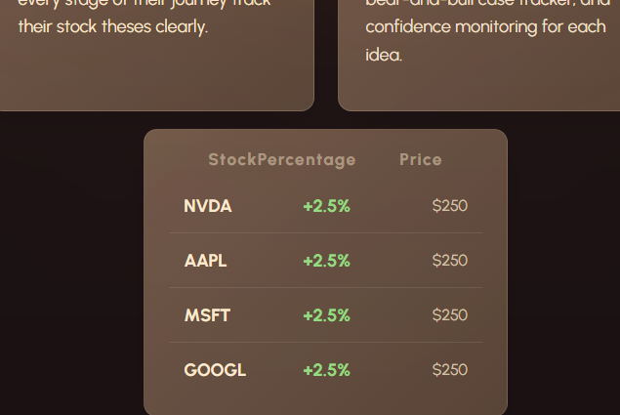 | I restyled the Stock ticker list so that it looks more visually appealing and fills up more of the screen  What I changed / did in terms of code:

